ICGG-12  International Conference on Gas Geochemistry 2013  Patras, Greece, 1-7 September 2013 | 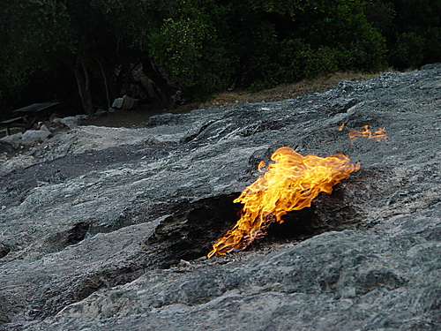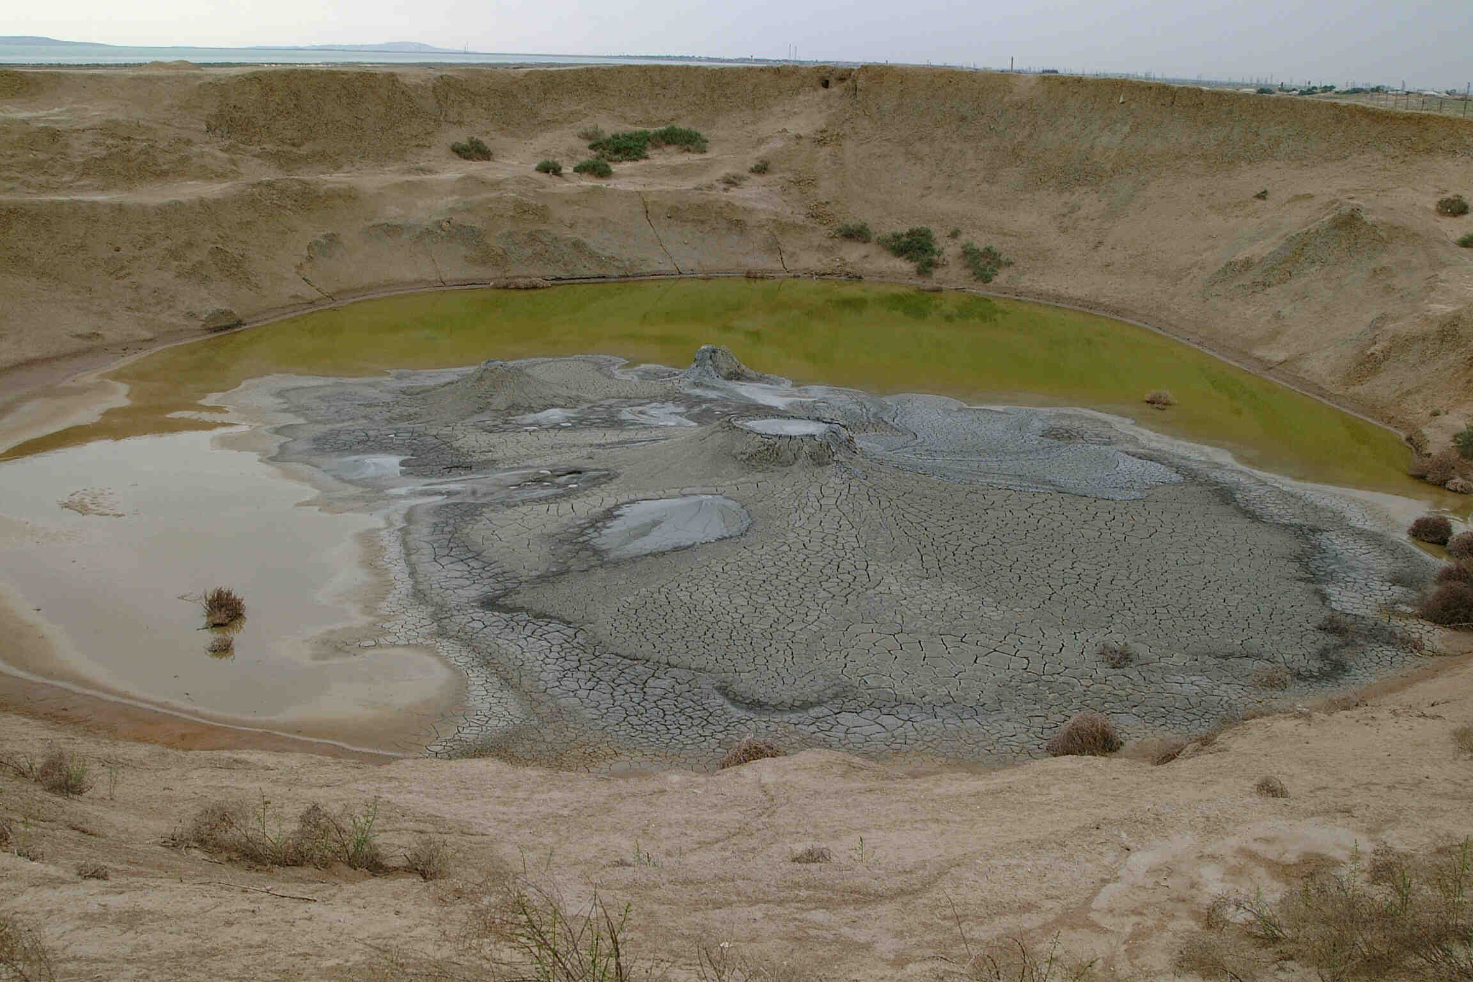
The International Conference of Gas Geochemistry (ICGG) is an international forum where the latest research and technological advances related to gas geochemistry are presented and discussed. This is the twelfth of the ICGG series which started in 1982 to unite experts in gas geochemistry, working on various geological and environmental issues. The objective of the ICGG-12, which is to be held in Patras, Greece, is to promote international and interdisciplinary exchange of information, to foster co-operation among researchers in academia, research institutes, private companies, and industry and to stimulate growth and advances in the field of gas geochemistry.
ICGG-12 Patras will cover all the main scientific topics associated with gas geochemistry (carbon dioxide, methane, gaseous hydrocarbons, nitrogen, oxygen, noble gases, radon) from the perspective of different geosystems (volcanic-geothermal systems, sedimentary basins/petroleum reservoirs, crystalline rocks, ophiolites, submarine environment, groundwaters) as well as cross-cutting topics (gas origin and migration, Earth evolution and degassing, natural hazards, environmental monitoring, palaeoclimate reconstructions, new techniques and measurements).
Date and Venue
The conference will take place in Patras, Greece, at the Conference & Cultural Center of the University of Patras, on September 1-7, 2013, the week immediately after the Goldschmidt Conference at Florence, Italy.
Agenda
ICGG-12 will start with an ice-breaker session following registration during the late afternoon and early evening of Sunday 1st September.
We foresee 4 days of oral and poster sessions (Monday to Thursday) with a daily on-site lunch-break and various social events. Each day will feature an invited Keynote Lecture.
Featured Keynote Speakers: Pending
Field trips:
Two daily fieldtrips to the main areas with natural gas emissions coupled with archaeological interest in Greece are proposed for September 6 and 7, 2012.
Field trip 1
On September 6, 2012, a field trip will take place in Western Greece and the Katakolo area with impressive on-shore and off-shore natural gas seepage. A short boat trip over the underwater natural gas seepage area will take place where a Remotely Operated Vehicle (R.O.V.) will be deployed. Also the birthplace of the Olympic Games, the archaeological site of Ancient Olympia will be visited.
The field trip expenses include the transportation fee from and back to Patras, museum and archaeological site tickets and one meal. Participation in the first field trip in Katakolo and Ancient Olympia costs 60 € per person.
Field trip 2
On September 7, 2012 the second field trip will include a visit to Delphi Oracle, one of the most important archaeological sites in Greece, which is also an ancient natural gas seepage area.
The field trip expenses include the transportation fees from and back to Patras, museum and archaeological site tickets and one meal. Participation in both field trips costs 110 € per person.
Field trip expenses are additional to the registration fee.
After the completion of each field trip we will return to Patras late in the afternoon.
 | Sunday Sept. 1 | Monday Sept. 2 | Tuesday Sept. 3 | Wednesday Sept. 4 | Thursday Sept. 5 | Friday Sept. 6 | Saturday Sept. 7
Morning | - | Presentations | Presentations | Presentations | Presentations | Field Trip | Field Trip
Afternoon | Registration | Presentations | Presentations | Presentations | Presentations | Field Trip | Field Trip
Evening | Ice breaker | Free | International Committee Business Meeting | Conference dinner | Drinks | Free | Free

Important Dates
- January 1th, 2013 – Registration and Abstract Submission open
- May 1st, 2013 – Abstract Submission deadline
- September 1st, 2013 (Sunday) – On-site registration and conference ice-breaker (evening)
- September 2nd – September 5th, 2013 (Monday – Thursday) – Conference sessions (4 days)
- September 6th - September 7th, 2013 (Friday-Saturday) – Conference field-trips (optional)

Abstract submission and papers publication
Conference fees  Full registration Before May 1st, 2013 370 €  After May 1st, 2013 450 €  Student Before May 1st, 2013 100 €  After May 1st, 2013 150 €  Accompanying person Before May 1st, 2013 100 €  After May 1st, 2013 150 € | Field-trip fees  Field trip 1, September 6, cost 60 €  Field trips 1 & 2, September 6 and 7 cost 110 €  May 1st, 2013 Confirmation of field trip participation
All participants are kindly requested to submit their abstract by May 1, 2013. The on-line submission will be available in January 2013. The authors will be notified by May 31 about the acceptance of their contributions.
The Organizing Committee is contacting international SCI for publishing the Conference papers.

ICGG International Committee ICGG 12 Organizing committee
- Baciu, C. (Romania)  - Chalupnik, S. (Poland)  - Chyi, L.L. (USA)  - Duan, Z. (China)  - Etiope, G. (Italy)  - Heinicke, J. (Germany)  - Hilton, D.R. (USA)  - Italiano, F. (Italy)  - Kies, A. (Luxembourg)  - Martinelli, G. (Italy)  - Marty, B. (France) | - Papatheodorou G. (Greece)  - Pérez, N.M. (Spain)  - Singh, S. (India)  - Solecki, A. (Poland)  - Taran, Y. (Mexico)  - Wang Y. (China)  - Waseda, A. (Japan)  - Woith, H. (Germany)  - Yang, T.F. (Taiwan)  - Yuce, G. (Turkey) | - George Papatheodorou (University of Patras, Department of Geology)  - Avraam Zelilidis (University of Patras, Department of Geology)  - George Ferentinos (University of Patras, Department of Geology)  - Maria Geraga (University of Patras, Department of Geology)  - Stavroula Kordella (University of Patras, Department of Geology)  - Dimitris Christodoulou (University of Patras, Department of Geology)  - Margarita Iatrou (University of Patras, Department of Geology)  - Vasilios Lykousis (Hellenic Centre for Marine Research)

Contact
Dr. George Papatheodorou  Department of Geology, University of Patras, Patras, 26504 Greece  Email: gpapathe@upatras.gr  - Phone: +302610996275  - Fax: +302610996275 | Dr. Margarita Iatrou  Department of Geology, University of Patras, Patras, 26504 Greece  Email: iatroum@upatras.gr  Phone: +302610996295
Conference Web-site: http://conf12.ic-gg.org

